horizontal line

**SUBJECT CODE - EP201**

INTRODUCTION TO COMPUTING

**PRACTICAL FILE**



**SUBMITTED BY: ADITYA SINGH**

**ROLL. NO: 2K19/EP/005**

**BRANCH/SEM: EP/3rd Sem**

**SUBMITTED TO: DR. AJEET KUMAR**

**LIST OF EXPERIMENTS**

1. Basics of Matrix operation and Matrix manipulation

2. Write a Matlab program for very famous Blackbody radiation and verify Wein’s displacement law.

3. Write a Matlab program to show the binding energy/mass number with mass number to find the most stable state.

4. Write a Matlab program to calculate the values of inbuilt defined trigonometric functions using series solution approach. Compare the results with inbuilt functions.

5. Write a Matlab program to study the behavior of Gaussian function using all appropriate inbuilt 2d and 3d plotting commands.

6. Write a Matlab program to find out the unknown coefficients by Polynomial fitting.

7. Write a Matlab program to solve the second order differential equation of the pendulum problem.

8. Write Matlab code to plot the intensity distribution of Single-slit, double slit and N-slit all together. Analyze the result. Show how young’s double slit experiment is different from the double slit diffraction.

9. Write a Matlab program to find out the roots of a given equation using the bisection method. Compare the results using Matlab inbuilt functions.

10. Write Matlab code to show the propagation of a group wave as a function of time.

**CONTENTS**

|  |  |  |  |
| --- | --- | --- | --- |
| **S.NO** | **Experiments** | **Page** | **Remarks** |
| 1. | Basics of Matrix operation and Matrix manipulation | 1 |  |
| 2. | Blackbody radiation and verify Wein’s displacement law. | 4 |  |
| 3. | Binding energy/mass number with mass number to find the most stable state. | 6 |  |
| 4. | Calculate the values of inbuilt defined trigonometric functions using a series solution approach. | 8 |  |
| 5. | Behavior of Gaussian function using all appropriate inbuilt 2D and 3D plotting commands. | 9 |  |
| 6. | Find out the unknown coefficients by Polynomial fitting. | 11 |  |
| 7. | Second order differential equation of the pendulum problem. | 12 |  |
| 8. | Intensity distribution of Single-slit, double slit and N-slit all together. | 13 |  |
| 9. | roots of a given equation using  bisection method. | 15 |  |
| 10. | Propagation of a group wave as a function of time. | 16 |  |

**Experiment 1:** Basics of Matrix operation and Matrix manipulation.

**Code/Commands:**

A = [1 2 8; 5 6 1; 4 3 7]; B = [5 6 2; 8 2 3; 1 5 9];

a = A+B e = A*B i = A/B m = inv(A)

b = B+A f = B*A j = B/A n = A\B

c = A-B g = A.*B k = A'

d = B-A h = B.*A l = diag(A)

%RESHAPE

A = [1 2 8; 5 6 1]

o = reshape(A,3,2) s = flip(A)

p = rot90(A) t = ctranspose(A)

q = fliplr(A) u = tril(A)

r = flipud(A) v = triu(A)

%CONCATENATION

C = [B B; B+4 B-1]

C(:,2) = [ ]

w = max(B)

whos B

**OUTPUT:**

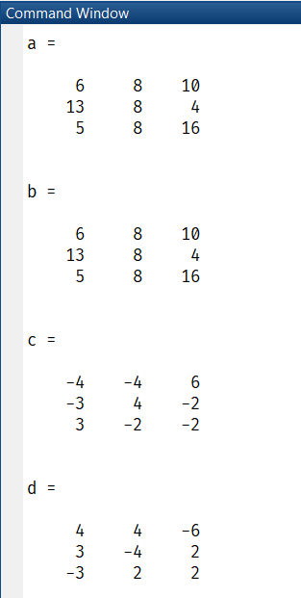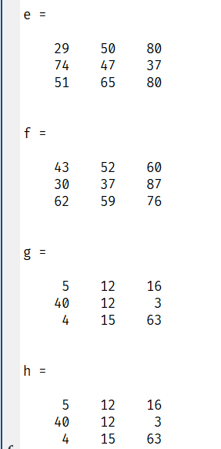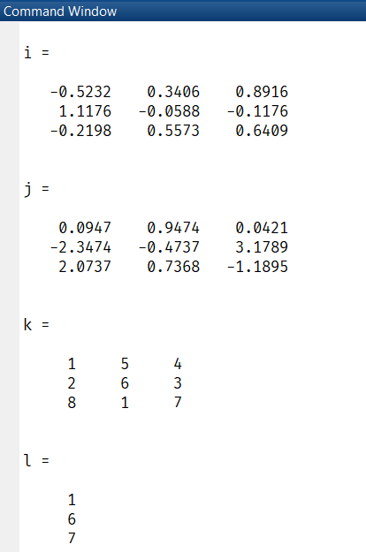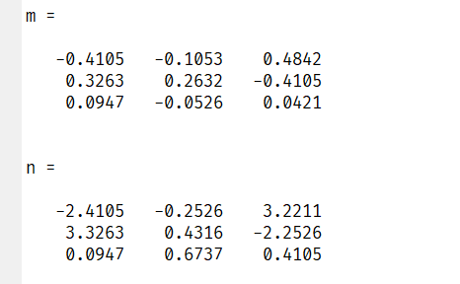

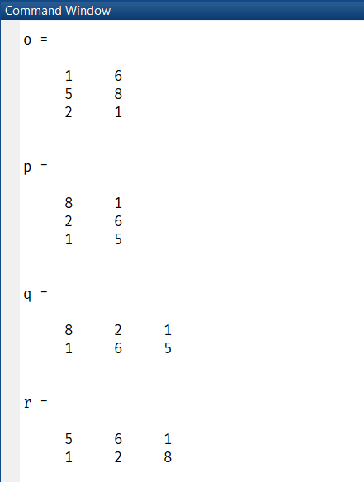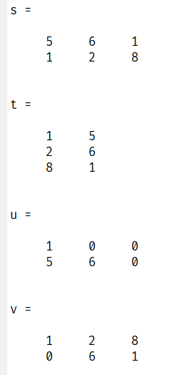

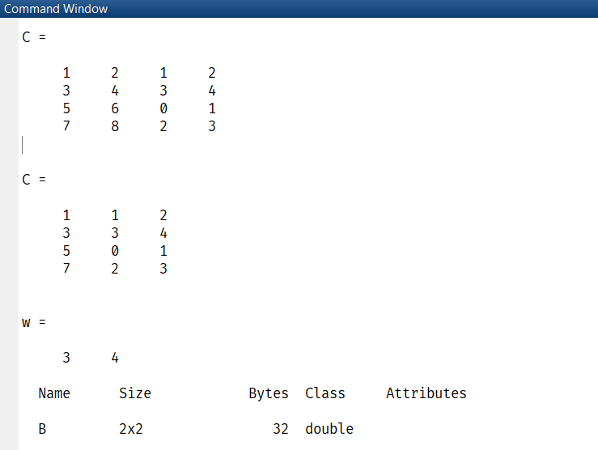

**Experiment 2**: Write Matlab program for very famous Blackbody radiation and verify Wein’s displacement law.

**Code/Commands:**

c=3*10^8; % speed of light in vacuum

h=6.625*10.^-34; % Planck constant

k=1.38*10.^-23; % Boltzmann constant

T=[ 500 600 700 ]; % Temperatures in Kelvin

Lam=(0.0:0.01:20).*1e-6;

for i=1:3

% Wien's Displacement Law

I1(:,i)= ((2*h*c*c)./(Lam.^5)).*(exp(-(h*c)./(Lam*k*T(i))));

% Planck's Law

I2(:,i)=(2*h*c*c)./((Lam.^5).*(exp((h.*c)./(k.*T(i).*Lam))-1));

plot(Lam,I1(:,i))

hold on

plot(Lam,I2(:,i),'r')

text(.55e-5,.7e8,'T=500K')

text(.5e-5,2e8,'T=600K')

text(.8e-5,5e8,'T=700K')

legend('Wien's Law', 'Planck's Law')

xlabel('\lambda')

ylabel('Intensity')

title('Blackbody Radiation')

end

**OUTPUT:**

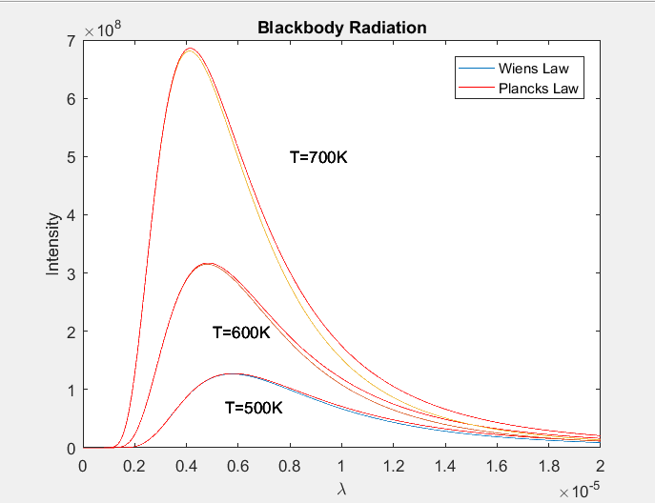

**Experiment 3**: Write Matlab program to show the binding energy/mass number with mass number to find the most stable state.

**Code/Commands:**

av = 14.1; % Volume coefficient

as = 13.0; % Surface energy coefficient

ac = 0.595; % Coulomb energy coefficient

aa = 19.0; % Asymmetric energy coefficient

ap = 33.5; A = 2:1:300;

Z = (1/2)*A./(1+A*(2/3)*(ac/4*aa));

N = A.*(-Z);

b = mod(Z,2); % Check Even

c = mod(A,2);

if b==c

if c==0

BE=av-(as/A.^(1/3))-(ac*Z.^2./A.^(4/3))-(aa*((A-(2.*Z)).^2)./A.^2)+(ap./A.^(7/4));

elseif b==1

BE=av-(as./A.^(1/3))-(ac*Z.^2./A.^(4/3))-(aa*((A-(2.*Z)).^2)./A.^2)-(ap./A.^(7/4));

end

else

BE=av-(as./A.^(1/3))-(ac*Z.^2./A.^(4/3))-(aa*((A-(2.*Z)).^2)./A.^2);

end

plot(A, BE./A)

xlabel('Mass Number');

ylabel('Binding Energy/Mass Number')

title('Binding Energy/Mass Number vs Mass Number')

**OUTPUT:**

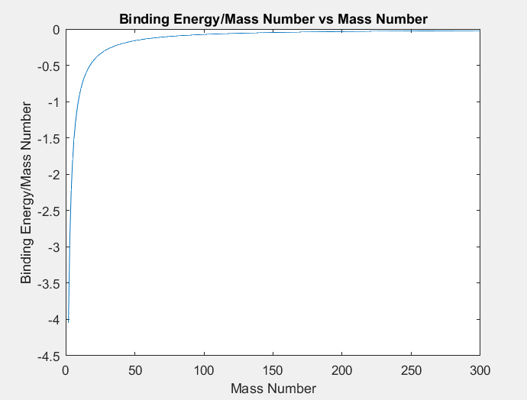

**Experiment 4**: Write Matlab program to calculate the values of inbuilt defined trigonometric functions using series solution approach. Compare the results with inbuilt functions.

**Code/Commands:**

n = 100;

x = pi/3;

a = zeros(1,n);

b = zeros(1,n);

for i = 0:n

a(i+1) = (-1)^i*x^(2*i+1)/factorial(2*i+1);

b(i+1) = (-1)^i*x^(2*i)/factorial(2*i);

end

sinx_series = sum(a)

sinx_inbuilt = sin(x)

cosx_series = sum(b)

cosx_inbuilt = cos(x)

**OUTPUT:**

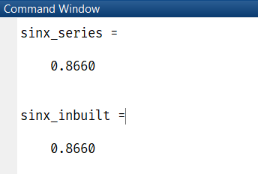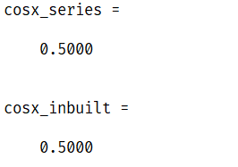

**Experiment 5**: Write Matlab program to study the behavior of Gaussian function using all appropriate inbuilt 2d and 3d plotting commands.

**Code/Commands:**

x=linspace(-3, 3,100);

y=x;

[X,Y]=meshgrid(x,y);

z=exp(-(X.^2/2)-(Y.^2/2));

y1=exp(-(x.^2/2));

figure;

surf(X,Y,z);

xlabel('X axis '), ylabel('Y axis '), zlabel('Z axis');

title('Gaussian function - 3D Plot');

colorbar

shading interp

axis tight

figure;

plot(x,y1);

xlabel('X axis '),ylabel('Y axis ');

title('Gaussian function - 2D Plot');

**OUTPUT:**

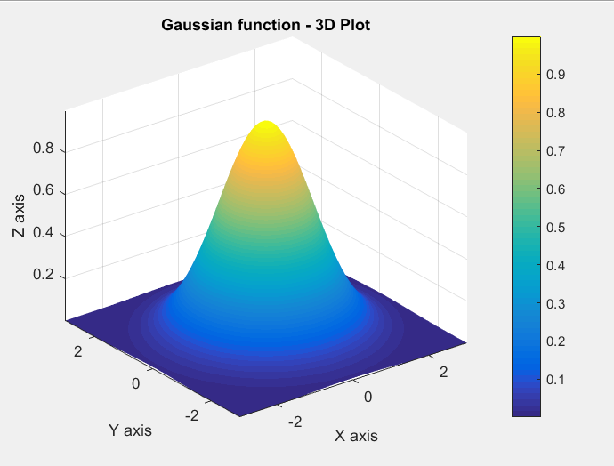

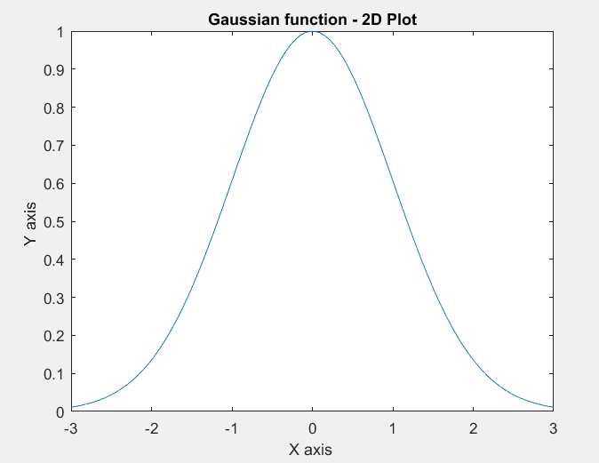

**Experiment 6**: Write Matlab program to find out the unknown coefficients by Polynomial fitting.

**Code/Commands:**

t = [0 0.5 1.0 5.0 10.0 20.0]; p= [760 625 528 85 14 0.16];

tbar = t ; pbar = log(p);

a = polyfit(tbar,pbar,1);

tau = -1./(a(1)); p0 = exp(a(2));

disp(['Coefficients : tau = ' num2str(tau) ' & p0 = ' num2str(p0)]);

tnew = linspace(0,20,20); pnew = p0 .*exp(-tnew./tau);

plot(t,p,'go',tnew,pnew),grid;

xlabel('Time (sec)'), ylabel('Pressure (torr) ');

title('Polynomial Fitting');

legend('data values points','curve fitting');

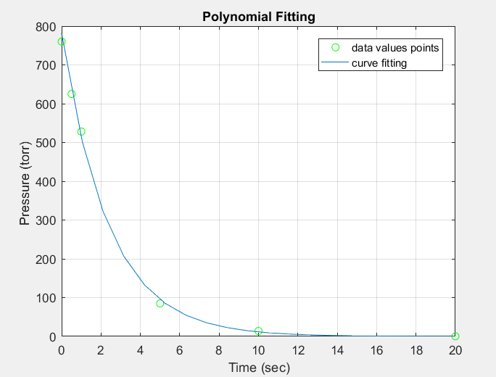

**OUTPUT:**



**Experiment 7**: Write a Matlab program to solve the second order differential equation of the pendulum problem.

**Code/Commands:**

m=0.8; l=0.613; B=0.095; g=9.8;

pendulum = @(t,x) [x(2);-B/m*l.*x(2)-g/l.*sin(x(1))];

tspan = [0,50]; x0 = [pi/2,0];

[t,x] = ode45(pendulum,tspan,x0);

plot(t,x(:,1),'k');

grid on; hold on;

plot(t,x(:,2),'m');

xlabel('Time (sec)'); ylabel('Amplitude');

legend('Angle (rad)','Angular Velocity (rad/sec)');

title('Second Order Differential Equation of Pendulum');

**OUTPUT:**

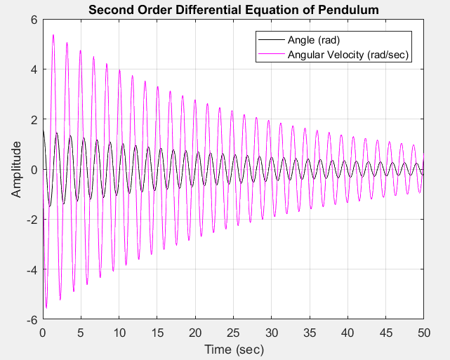

**Experiment 8**: Write Matlab code to plot the intensity distribution of Single-slit, double slit and N-slit all together. Analyze the result. Show how young’s double slit experiment is different from the double slit diffraction.

**Code/Commands:**

e=0.14*(10^(-3)); Io=1; d=5*e;

lambda=5500*(10^(-10));

theta=-20:0.001:20;

% Single slit

a=(pi.*e.*sind(theta))./lambda;

Is=(Io.*(sind(a)).^2)./((a).^2);

% Double slit

beta=(pi*(e+d).*sind(theta))./lambda;

Id=(4*Io*(sind(a)).^2.*(cosd(beta)).^2)./((a).^2);

plot(theta,Is,'y'); hold on; plot(theta,Id)

xlabel('\theta'); ylabel('Intensity')

% N slit

N = 3; % for n=3

In=Io*(((sind(a)).*(sind(N*beta)))./(a.*sind(beta))).^2;

[In_max,I]=max(In); In_norm=In./In_max;

plot(theta,In);

% Young's Double Slit Exp

ey=e/1000; ay=(pi.*ey.*sind(theta))./lambda;

beta_y=(pi*(ey+d).*sind(theta))./lambda;

Id_y=(4*Io*(sind(ay)).^2.*(cosd(beta_y)).^2)./((ay).^2);

plot(theta,Id_y); hold off

legend('Single slit','Double slit','N=3 slit','Young Double Slit')

title(' Intensity distributions')

**OUTPUT:**

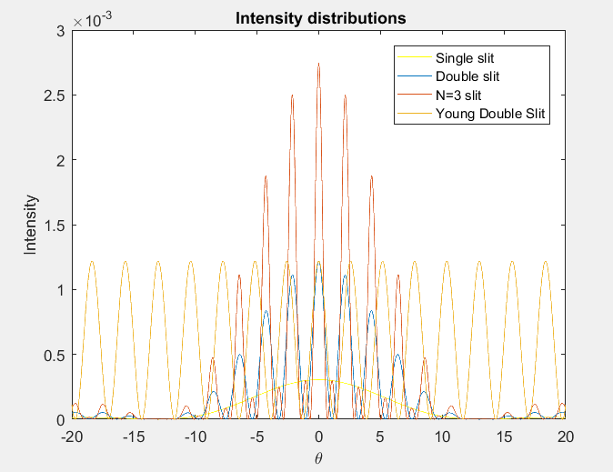

**Experiment 9**: Write a Matlab program to find out the roots of a given equation using bisection method. Compare the results using Matlab inbuilt functions.

**Code/Commands:**

f=@(x) x.^2-6;

x_lower=0; x_upper=5;

x_mid=(x_upper+x_lower)/2;

while abs(f(x_mid))>0.01;

if (f(x_mid)*f(x_upper))<0;

x_lower=x_mid;

else

x_upper=x_mid;

end

x_mid=(x_upper+x_lower)/2;

end

p=[1 0 -6]; r=roots(p);

fprintf(['Root obtained by Bisection Method: ',num2str(x_mid),'\n']);

fprintf('Roots obtained by Inbuilt Function are: \n');

disp(r);

**OUTPUT:**

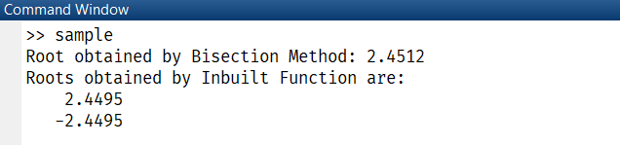

**Experiment 10**: Write a Matlab code to show the propagation of group wave as a function of time.

**Code/Commands:**

x=-500:1:500;

a=0.01;

for t=0:1:50

y=0.01.*cos((0.01.*x)-(0.002.*t)).*cos((0.2.*x)-(2.*t));

plot(x,y)

pause(0.10)

end

**OUTPUT:**



**ANNEXURE**

% CIRCLE OF RADIUS R

r=10; th = linspace(0,2*pi,100);

x =0; y=0;

cx = r.*cos(th) + x;

cy = r.*sin(th) + y;

plot(cx,cy); xlabel(‘x’); ylabel(‘y’); title('circle of r=10');

% RELATIONAL OPERATORS < <= > >= ==

A = [1 2 3; 4 5 6; 7 8 9]; B = [4 5 6; 1 2 3; 7 8 9];

A == B A<=B A>B

% LOGICAL OPERATORS & | ~

C = [0 0 1 1]; D = [0 1 0 1];

C&D C|D ~C

% SORT FUNCTIONS

% sort(matrix, dimension) dimension = 1(for column-wise), 2(for row-wise)

E = rand(3,5)*10 F = sort(E,1)

G = sort(E,2,'descend') % for descending order

% sum of series 5x^2-2x not to exceed 1500

sum=0;i=1; count=0;

while sum<=1500

sum = sum + 5*i^2-2*i;

i=i+1;count=count+1;

end

count

hold on % retains previous graph and shows in next plot

subplot % multiple plots in same window

subplot(m,n,p) % divides the figure in mxn grid and create axes in the position specified by p

format short/ long/ e/ long g/ short g/ bank/ hex % default is - format short

ceil(x) % nearest greater

floor(x) % nearest smaller

fix(x) % rounds towards zero

[M,I] = max(A) % max element with index in every column.

% fibonacci series

n = input('enter num: '); fibo = [1,1];

for i=3:n

fibo(i)=fibo(i-1)+fibo(i-2);

end

POLYNOMIALS - defined in MATLAB as a row vector, made up of coefficients. Dimension of row vector=n+1; n=degree of the polynomial.

p = [3 4 1]; % 3x^2 + 4x + 1

polyval(p,[5 7 4]) % It returns the value of a polynomial of degree n evaluated at x

CURVE FITTING - process of adjusting a mathematical function so that it lays as closely as possible to a set of data points. Curve fitting is based on " LEAST SQUARES TECHNIQUE". This technique minimizes the squared errors b/w the curve and set of measured data.

p = polyfit(x,y,n);

% p = vector of coefficients of polynomial that fits the data

% x = vector of horizontal coordinates of data points (independent)

% y = vector of vertical coordinates of data points (dependent)

% n = degree of polynomial

% ROOTS OF POLYNOMIAL

z = [4 -3 2]; % 4x^2-3x+2

r=roots(z)

ANONYMOUS FUNCTIONS - not stored in a program file, but associated with a variable whose data type is function_handle.

Syntax: sqr=@(x) x.^2 [f(x)=x^2].

@=operator that creates the handle, (x) is the function argument.

k=@(x) x.^2; k(4) % output = 16

INLINE FUNCTION - it creates a function of any number of variables by giving a string containing a function followed by a series of strings denoting the order of the input variable.

% x=inline('expression')

l=inline('x.^2','x');

l(5)

l([4 6])

ROOTS OF NONLINEAR FUNCTION

% Syntax: x=fzero(func,x0)

f=@(x) sin(x) - 0.5;

n=fzero(f,[0 pi/2])

**END**